CHOOSE 54 OUNCES OF CEREAL  Use the Food List to choose brands and sizes that add up to 54 ounces.  Possible size combinations:  - 18oz. + 18 oz. + 18oz. = 54oz.  - 12oz. + 18oz. + 24 oz. = 54oz.  - 15oz. + 18oz. + 21oz. = 54oz.  You will also receive extra milk, eggs, cheese, and yogurt. Follow the quantities printed on your WIC checks to choose the right amounts.  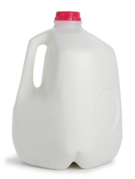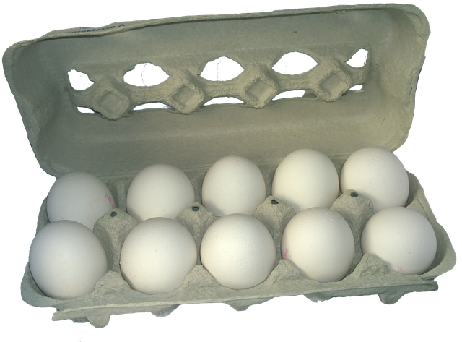 |  |  |  |  | CHOOSE 45 OUNCES of Canned fish  Choose canned tuna (5 or 6oz.), salmon (14.75oz.), sardines (3.75oz.), or jack mackerel (15oz.).  Possible combinations:  - Nine 5-oz. cans tuna = 45oz.  - Five 6-oz. cans tuna + three 5-oz. cans tuna = 45 oz.  - Three 14.75-oz. cans salmon = 44.25 oz.  - Twelve 3.75-oz. cans sardines = 45oz.  - One 14.75-oz. can salmon + three 6-oz. can tuna + three 3.75-oz. cans sardines = 44oz.  - Three 15-oz. cans jack mackerel = 45oz.  - One 15-oz. can jack mackerel + one 14.75-oz. can salmon + three 5-oz. cans tuna = 45oz. |  |  |  |  |  | DC WIC  Authorized foods for moms fully breastfeeding two or more babies
Congratulations on your choice to fully breastfeed your babies!  Be proud! You are giving your babies the gift of love and health that will last a lifetime.  Because you are fully breastfeeding more than one baby, you will receive more food than other breastfeeding mothers. Some of the foods are also different. Use the DC WIC Authorized Foods List and the Vendor Folder & Food List (image below) to select the correct foods.  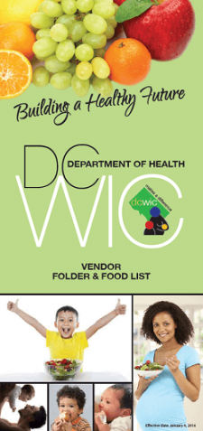 |  |  |  |  |  | CHOOSE 216 OUNCES OF 100% JUICE  Follow the Food List to choose four 48-ounce bottles of 100% juice. 12-ounce cans of frozen juice concentrate or shelf-stable juice concentrate can be substituted for a fluid 48-ounce bottle, if desired.  In addition, you may buy two 12-ounce bottles of single strength (regular) juice.  Possible options:  - Two 12oz. bottles Tropicana refrigerated Pure Premium 100% Orange Juice (any pulp content, can have added calcium and vitamin D)  - Two 12oz. bottles Simply Orange 100% Orange Juice  - Two 12oz. bottles Simply Apple 100% Apple Juice  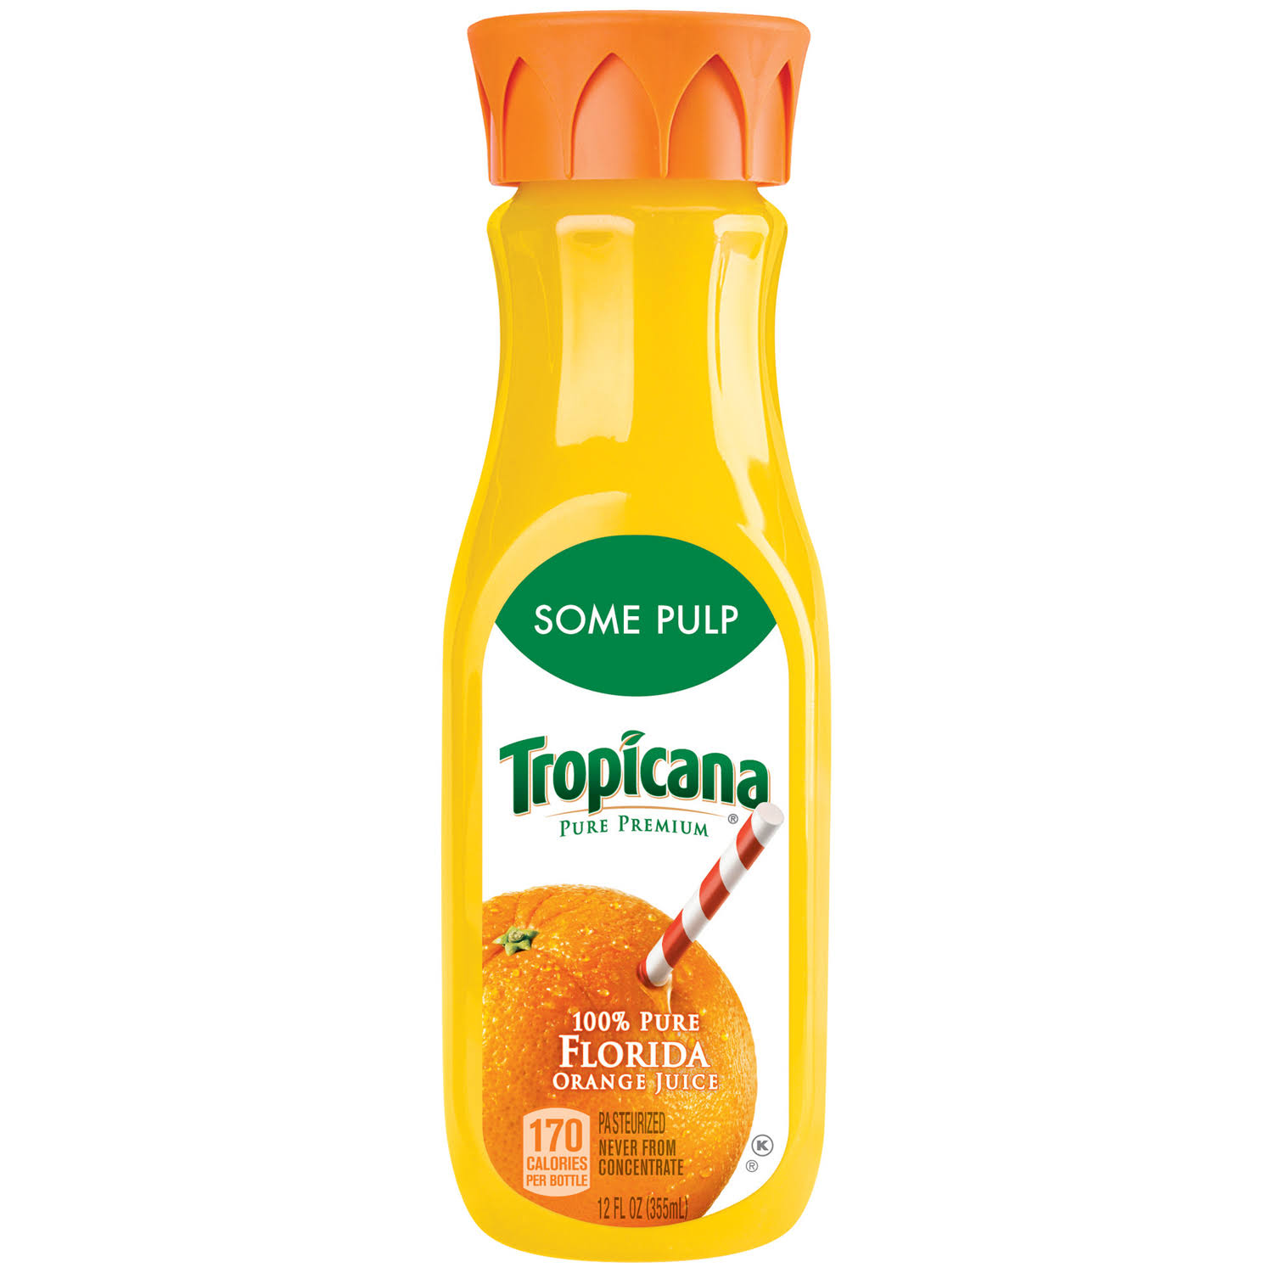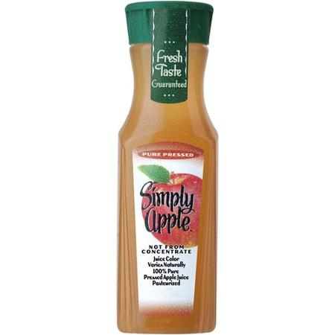 |  |  |  |  |  | Choose 24 Ounces From These 100% Whole grain choices  100% Whole Wheat Bread (24oz.):  - Pepperidge Farm Whole Grain 100% Whole Wheat  - Pepperidge Farm Farmhouse 100% Whole Wheat  - Arnold Whole Grains 100% Whole Wheat  - Arnold Country 100% Whole Wheat  - Stroehmann Dutch Country 100% Whole Wheat  Whole Oats (24oz.):  - McCann’s Steel Cut Irish oatmeal  - Open Nature Quick Cook Steel Cut Oats  - Harris Teeter Organics Steel Cut Oats  - Bob’s Red Mill Steel Cut Oats  There are currently no 24 oz. brown rice, whole wheat tortillas, or whole wheat pasta options available.

